Lab assignment 1

Artificial neural networks using back propagation

**Examiner Email**

Ning Xiong [**Ning.xiong@mdh.se**](mailto:Ning.xiong@mdh.se)

**Students name Email**

***Robin Calmegård*** [***Rcd10002@student.mdh.se***](mailto:Rcd10002@student.mdh.se)

***Dennis Stockhaus*** [***Dss10002@student.mdh.se***](mailto:Dss10002@student.mdh.se)

# **Abstract**

This rapport is for the first lab assignment of five in the course Learning Systems at Mälardalens University. In this first lab assignment the student or students are supposed to get an understanding how to use an artificial neural network and build their own representation of it. This assignment have predefined data that the network is supposed to train and test itself on. There are no restrictions on which programming language nor system.

# Background

This solution is built by C# (C-sharp)[1] programming language and for the moment it’s limited and is only available for Windows[2] systems. The solution uses the predefined graphical libraries that Microsoft [3]offers in their Integrated Development environment (IDE) *Visual Studio*[4] 2015.

# Implementation

The current implementation of the lab assignment is divided into separate components / model parts and each model have their specific functionality. Also this implementation is early stages of going to be redefined and built after the software architectural pattern *Model-View-View Model* (MVVM). Why we choose this pattern is because to separate *data* (model) from the *view* and make it less clustered and easier for reusability of the code.

## Artificial Neural Network

the learning algorithm used,

### The Reactive-Ion-Etching machines data

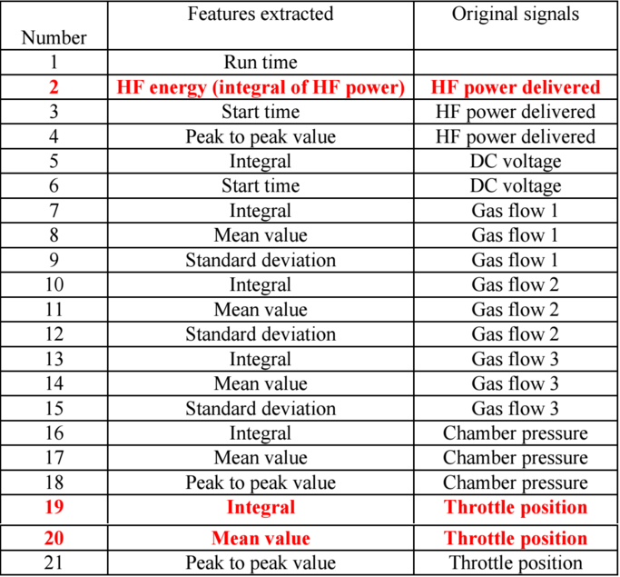

The image shows the different steps and there signals in the Reactive-Ion-Etching machines. Notice that there are three of these rows that are marked in red and bold text (rows are 2-19-21). These are the inputs for the ANN and the last row is the answer for the etching machine.

### Structure of neural network

the structure of neural network selected,

### Performance

the evolving of performance (errors with iterations),

#### Traning Data

performance on traning data

#### Test Data

performance on test data

# Result

Display graphs

1. <https://en.wikipedia.org/wiki/C_Sharp_(programming_language)> (Last accessed 2016-09-08)
2.
3.
4.